1) a) (15 points) Recalling acceleration is the second derivative of displacement, and given a constant acceleration in the horizontal and vertical directions, develop an equation for horizontal and vertical displacement as functions of time. Combine the two equations to eliminate time, t, as the independent variable to create a single CalcTool plot to include the following scenarios:

Given a target elevation of 5000MSL* and a constant, level-flight ground speed, plot [GBU-12](http://en.wikipedia.org/wiki/GBU-12_Paveway_II) no-wind ballistic trajectories for release from an MQ-9 at 25000MSL flying 150 KTAS**, from an A-10 at 15000MSL flying at 350 KTAS, and from an F-16 at 20000MSL flying at 550KTAS. Assume no wind, and no drag.

Calculate the distance from the target to release the ordnance.

Calculate the expected times of flight and impact angles (degrees).

b) (10 points) [JDAM](http://en.wikipedia.org/wiki/Joint_Direct_Attack_Munition)s allow improved accuracy when released by means of a “[loft](http://www.rand.org/content/dam/rand/pubs/rgs_dissertations/RGSD147/RGSD147.chap5.pdf)” or “toss” delivery. Break the velocity vector into its vertical and horizontal components determine the range and time of flight for loft deliveries 10, 20, and 40 degrees above the horizon, released from 500 feet AGL* and 550KTAS. Assume no-wind and no-drag. Eliminating time as the independent variable, plot all three on the same CalcTool graph for comparison.

Compare the ranges and times-of-fall to a level-flight (0 degree) delivery $.$

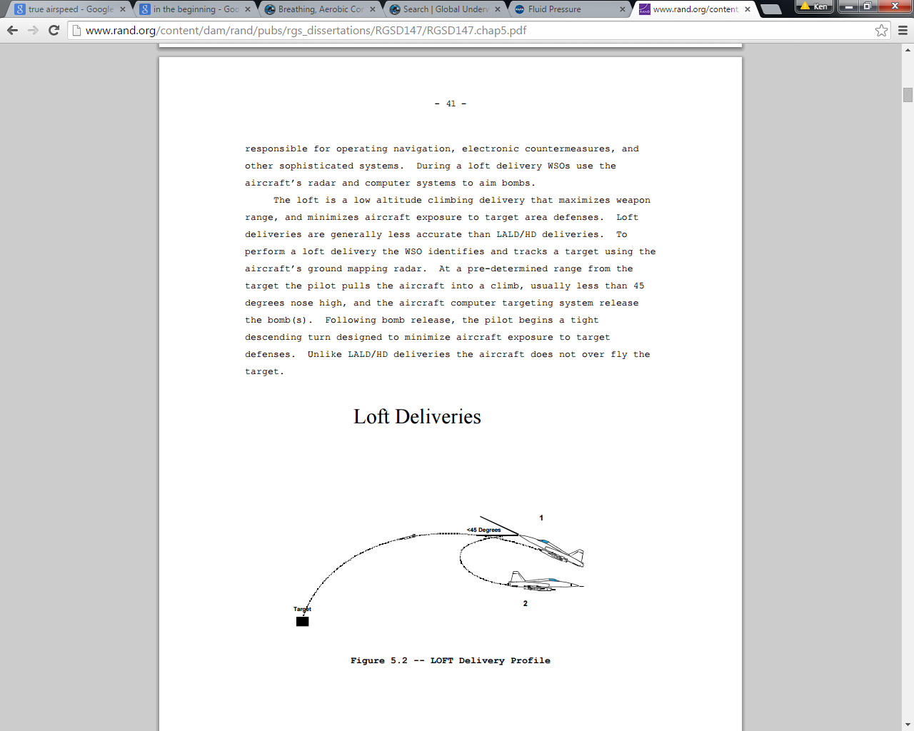(note: you may use your CalcTool plots to determine max-range, and each max-range to calculate times of fall)

*MSL = feet above Mean Sea Level. AGL = feet Above Ground Level

**KTAS = True Airspeed (knots) is the speed at which an aircraft is moving relative to the air that surrounds it.

GS = Groundspeed, which is TAS corrected for wind--the speed of the aircraft in relation to the ground.

Use 1nm = 6000ft

360degrees = 2

2) (25 points) A well-known parabolic enthusiast is considering two symmetric, custom aquariums; both are four feet tall (h = 0 to 4ft). One has a square base with sides of length s where h feet from the floor $s= \sqrt{π}\frac{h^{2}- 4h + 8}{8}$ ($ft$), and the other has a circular base with a radius, r where h feet from the floor $r=\frac{8 + 4h -{ h}^{2}}{8} (ft)$. Assume the walls will not deform, but are of negligible thickness and mass. Compare your results to two stock aquariums, both 4 ft tall—one with a square base s = $\sqrt{π} ft$, and a cylinder of r = 1 $ft$.

Draw the aquariums:

Volume ( $1 gal=7.48 ft^{3})$ square base: ______ gallons circular base: _______ gallons

Max Hydrostatic Pressure (psi) _______ psi ________ psi

Hydrostatic Force on base (lb) _______ lb ________ lb

Supporting Force (ie,weight of water) _______ lb ________ lb

Floor Pressure (psi) _______ psi ________ psi

Work to Fill from -60ft _______ ft-lb ________ ft-lb

Knowing that F = m*a, if the forces are unbalanced on either side of a body, it will accelerate in the direction of the greater force. Are the hydrostatic and supporting forces acting on the bottom surface of the aquariums balanced? Explain your results.

3) At rest, we [breathe](https://www.globalunderwaterexplorers.org/breathing-aerobic-conditioning-and-gas-consumption) 12 to 16 times a minute, with each breath averaging 6 to 8 milliliters (ml) per kilogram (kg) of body mass. Moderate intensity exertion will normally increase your respiration to 30 breaths per minute, but the human performance lab recommends breathing more deeply and regulating your breathing. **Assume 20bpm at 10ml/kg**.

Determine whether or not the team will be able to accomplish the proposed dive profile. If not, modify the profile to adhere as closely as possible, and explain any deviations. To assist in developing your solution, first answer the following questions:

a) (4 points) Assuming a constant temperature, [Boyle’s Law](http://en.wikipedia.org/wiki/Boyle%27s_law) tells us $P_{1}V_{1}= P_{2}V_{2}$, where P = Pressure and V = Volume. Using this relationship, how much volume will one (1) liter of Sea-Level-Pressure (SLP) air, occupy at 2, 3, 4 & 5 atmospheres of pressure? ___, ___, ___ & ___. (SLP = 1 atmosphere = 101325Pa, $1 Pa=1 N/m^{2}$)

b) (4 points)[***Ptotal***](http://www.grc.nasa.gov/WWW/k-12/WindTunnel/Activities/fluid_pressure.html)***= Patmosphere + Pfluid****.* Given a sea-water density of 1030 $kg/m^{3}$, at what depths will the hydrostatic pressure create an additional 1, 2, 3 & 4 atmospheres of pressure? (Hint: you might find it helpful to plot your dive profile in terms of atmospheres)

c) (4 points) A 15 liter tank pressurized to 2700psi contains how many liters of SLP air?

_______ Liters. (3447379 Pa = 500 psi)

d) (4 points) 2000 liters of SLP air compressed into 15 liters will require how much pressure?

_____ psi.

e) (4 points) Upon reaching the depth of 33 m, the team will complete a task of moderate intensity, requiring **40bpm**. The rate of Force (“dF/dt”) application to not exceed the prescribed respiration is directly proportional to the collective force ( “= k F”) of the team-members’ 10-rep maximum bench press. Crews with a collective force of 100 lbs can complete the task in 10 minutes, while crews with a collective force of 500 lbs can complete the task in 3 minutes. Derive both t(F) and F(t).

(15 points) The team consists of one 60 kg diver with a 13.2 liter tank and a 90 kg diver with a 15 liter tank. Their collective 10-rep max is 315 lb. All tanks start with a pressure of 2700psi. Team members will be tethered to each other with a 1m cord due to low visibility. While diving, conduct all ascents & descents at 3m/min

Descend along the anchor line to a depth of 15 meters.

Swim 10min at **15 meters** until the shelf

Decend to **33 m for ___** minutes, breathing at **40 bpm**.

Return to **15 meters** for 10min to return to the anchor point

Remain for 5 minutes at **3m** to [denitrogenate](http://www.merriam-webster.com/medical/denitrogenate)

Surface with at least 200psi

In one-minute intervals, scale the plot of the dive profile and tank pressure to fit on a single graph.

Calculate the tank pressure upon dive completion for each diver: ____ & ____

(15 points) Given two 13.2 liter, and one 15 liter dive tanks, can YOUR project team complete the profile? If not, what modifications will you need to make?

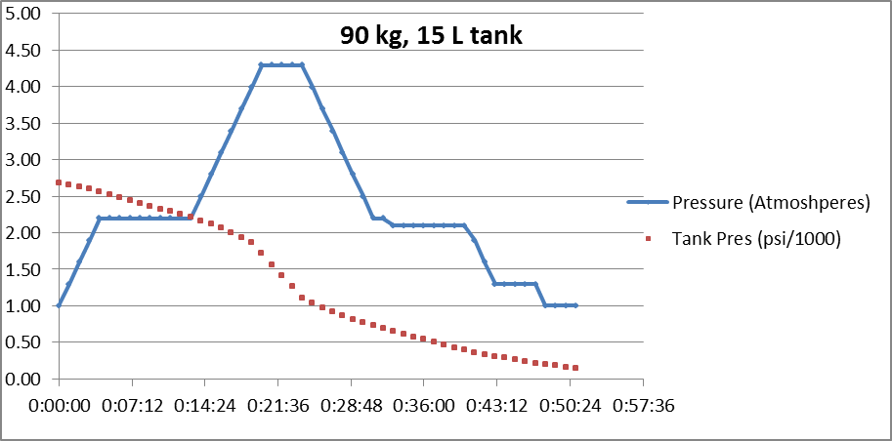

**60 kg, 13.2 L tank**